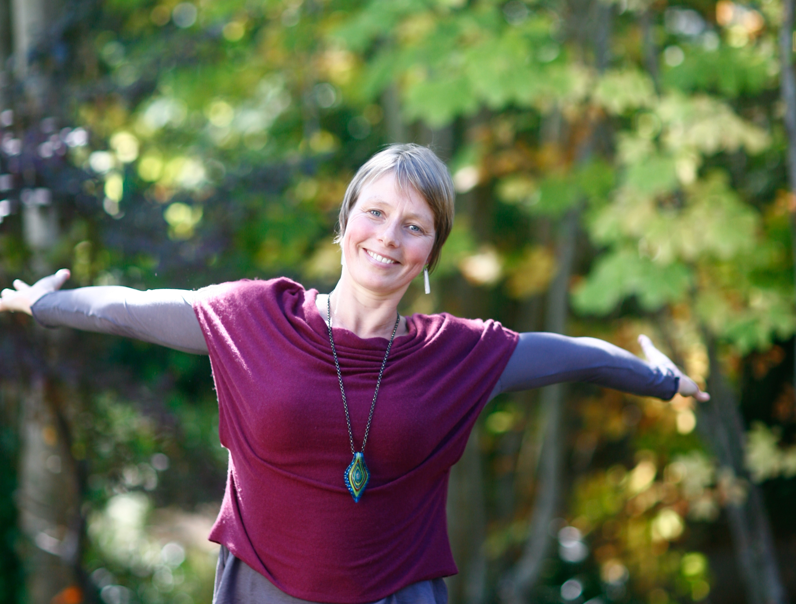

Inga Michaelsen

415 Wilkie Way, Salt Spring Island, BC V8K 2J4

Phone: 250-538-0200 Email: Inga Michaelsen

Web: freebird-coaching.com

**Objective:**

I believe that my diverse life experience, my love to work and connect with people and my deep understanding of the co-active model will make me an ideal candidate for the Front of the Room Leadership role. What I will bring to this position is my unconventional way of looking at the world, allowing the participants to look outside of their familiar boxes. I am also committed to live with an open heart, to be vulnerable, to bust fears and doubts and to teach and inspire others to do the same. I am a great team player and truly thrive on the co-creative process with fellow CTI people.

**Experience**:

*2012/13:*

Started hosting numerous workshops based on the co-active model.

Vision Boards, “Wake Up” workshops, “Who is speaking” (twist on Captain & Crew/Saboteur), New Year resolutions, Conscious Divorce; to name the title of a few.

*2012:*

I founded Freebird Coaching & Leadership, my own coaching and leadership training business.

*2010- current:*

I assist Sam Darling with the beginning stages of the Del Cielo Project, a global humanitarian health initiative with the goal to protect poor communities from vector born diseases (i.e. Malaria) with a low coast, non-toxic, highly effective mosquito repellent. My role as a personal assistant is multi-facet; from designing a website to meeting and connecting with stakeholders in Africa and South America, to going to conferences on tropical diseases. This job has been a great opportunity to demonstrate my ability to be flexible, to dance in the moment and believing that what you don’t know can be learned and when creative you can solve any problem.

*2008 – current:*

I have been teaching yoga on and off in Mexico and our local Yoga centre. Most of the time I offer it for free and love the practice and teachings. It has been my first introduction to a spiritual practice and I am drawing many parallels between co-active work and yoga.

*2010-12*

I participated in developing a property on Salt Spring Island into a community farm. This included a lot of hard physical work as well as writing a business plan and hosting meetings with potential community members. As my husband and I separated, I am not involved in this project any longer. However, I still feel very strongly about co-active communities and creating a sustainable way of living together.

*2009-2010:*

Traveled for a year with my family. I am an adventurer and love exploring the world and different cultures. Though, we are shaped by our social conditioning, I am always struck at how much the same, in our unique way, we humans all are.

*Since 2004:*

I am a mother of two boys, now 7 & 9 years old. In my opinion one of the most challenging and rewarding roles one can have is to experience being a parent. These boys have been primarily responsible to teach me about love, fears, creativity and curiosity, to be in the moment, to be patience and to stretch constantly.

*Between 2004 – 2008:*

During this time I worked as a manager of our coffee shop in Whistler, BC. Knowing what I now know, I didn’t do the best job managing at that time. However, I learned a lot about what it take to run a business and to manage people poorly. I also worked as a bookkeeper and posses basic accounting skills.

*Between 2000 – 2004:*

Shortly after graduation and a year at university in Germany, I moved to Canada in 2001. The first 8 years I lived in Whistler, BC before recently moving to Salt Spring Island, BC. In Whistler I worked in different Tourism related jobs and with disabled people, supporting them with recreational activities and in a school setting.

**Education:**

2011-2013: CTI Core Curriculum and Leadership Training

2008: 200hrs Yoga teacher training at the Salt Spring Centre of Yoga.

2001-2003: Tourism Management Diploma. Capilano College, Vancouver.

1997 – 1998: High-School Exchange Student in Wetaskiwin, Alberta.

**Skills:**

*Mindful Living*

In my opinion this is an important aspect of what is necessary to live a co-active life and it is a life long practice. Through my yoga practice, my spiritual and my CTI journey, I have gained a lot of awareness of what it means to live mindfully. I am able to teach and assist people to raise their consciousness through opening them up to their spiritual knowing.

*Love*

Love is obviously not a skill but a state of being and an awareness. However, not enough people know what connecting to the consciousness of love feels like. I am extremely grateful to have had my own experiences and have made it my life purpose to align myself with it and to support others to experience the same. That is one of the reasons why I am excited to apply for this position, because CTI does such a great job giving people a sense of love and intimacy if they are willing to open themselves to it.

*Small Business acumen*

Through my studies of Tourism Management, being married to a small business owner, having worked in accounting and now building my own business, I am adapt to what it takes to run a micro business and have a clear idea of what it means to run a larger company. I am organized, flexible and willing to shoulder responsibilities. My openness to learn new skills and to ask for help if needed allows for continued growth in this area.

*Communication skills*

I love what I have learned about communication throughout my CTI leadership program and working with the co-active leadership model has become a big part of my life. So I am getting better at staying, acting on my urges, responding versus reacting and especially RECOVERING.

I am an earnest person, kind and friendly. I can relate to a large variety of people and find it easy to adapt (now merge and lead) in many different environments. I bring an earthiness to the room, grounded, calm and the willingness of going deep before expanding.

*Language*

German is my mother tongue and I speak English fluently.